**JFROG REPORT GENERATION PIPELINE SCRIPT**

Contents

1.1. Objective 1

1.2 Pre-requisites 1

1.3 How to Run the Script: 2

1.4 What each Variables Stands for: 2

1.5 Verification: 3

1.6 Script File location 3

1.1. Objective

The Objective of this script is generate Jfrog Reports via through Gitlab pipeline without login to JFROG UI using an Jfrog API.

1.2 Pre-requisites

Below are the pre-requisites before run the script

* Understand the JFrog APIs and Jfrog reports
* Create and place build.json in the repository you want to run the script in respective project with below contents ,REPORTNAME,TEMPLATE are constructor which will construct in script.

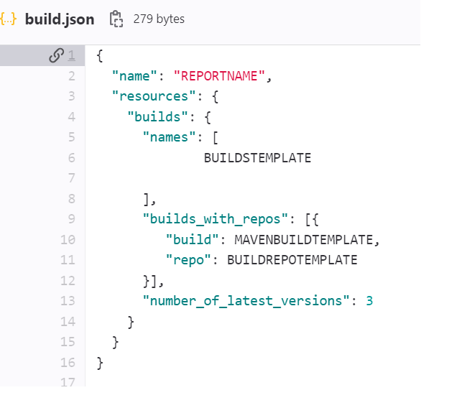

* Create a reports.json with below contents

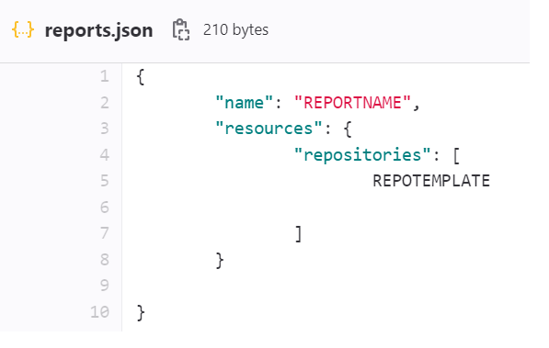

1.3 How to Run the Script:

There are four InputVariables requires. REPORT_TYPE REPORT_SCOPE , REPORT_FORMAT SCAN_START_DATE

# 1.4 What each Variables Stands for:

**REPORT_TYPE**

REPORT_TYPE is the Type of Report. There are mainly four type of reports. Out of that report we usually generate for Vulnerability and Violations of the repository and build. This variable is optional. If we are not specifying it, by default it will generate Vulnerabiliy Repository report.

**REPORT_SCOPE**

REPORT_SCOPE can be commonly for Builds, Repositories. This variable is optional. . If we are not specifying it, by default it will generate Vulnerabiliy Repository report.

**REPORT_FORMAT**

REPORT FORMAT can be either csv or pdf. **REPORT_FORMAT is mandatory user input variable**

**SCAN_START_DATE**

SCAN_START_DATE is optional variable. By default, yesterday’s date will pick up.

Click on RUN PIPELINE

Select respective Branch where your script resides. It should be main branch. In the below example branch select as report logic in POC-Vulnerability report and Report_FORMAT as csv. Default if we are not specify any date, it will take it as yesterday’s date.

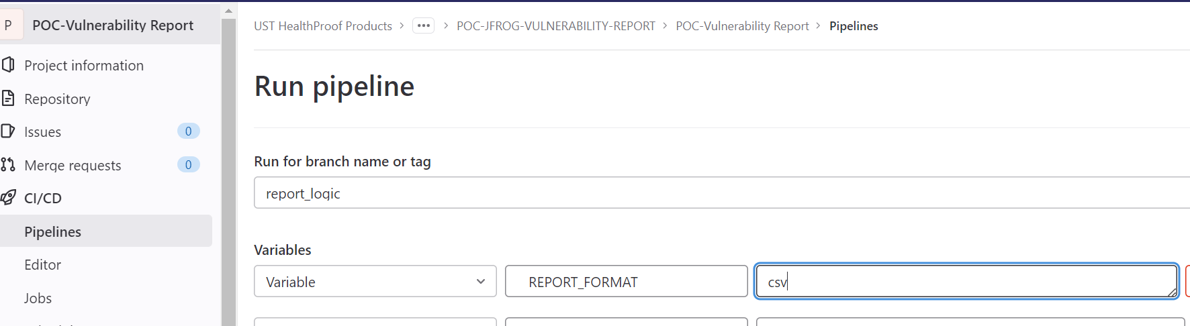

1.5 Verification:

Once you run the pipeline, you will see Job Succeeded and Uploading artifacts. And also you can download the report

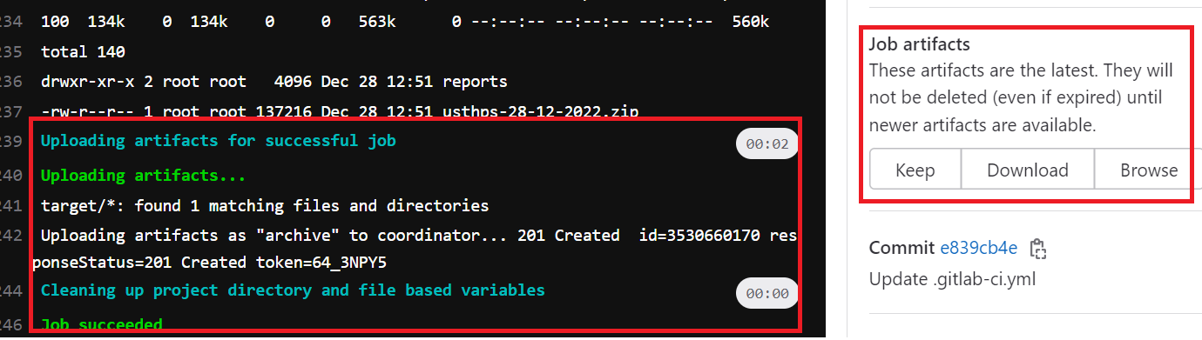

# 1.6 Script File location

<https://gitlab.com/usthealthproof-products/integration-plus/cicd/common-yaml-file.git> under [JfrogReportGeneration](https://gitlab.com/usthealthproof-products/integration-plus/cicd/common-yaml-file/-/tree/main/JfrogReportGeneration) Directory

|  |  |  |  |
| --- | --- | --- | --- |
| **#** | **Script File** | **Notes** | **Attachment** |
| 1 | Config.yml | Complete code for Generate report |  |
|  |  |  |  |